**wVe370 Introduction to Computer Organization Homework 3**

1. Exercise 2.31.1.
2. Exercise 2.31.2.
3. Exercise 2.31.3.

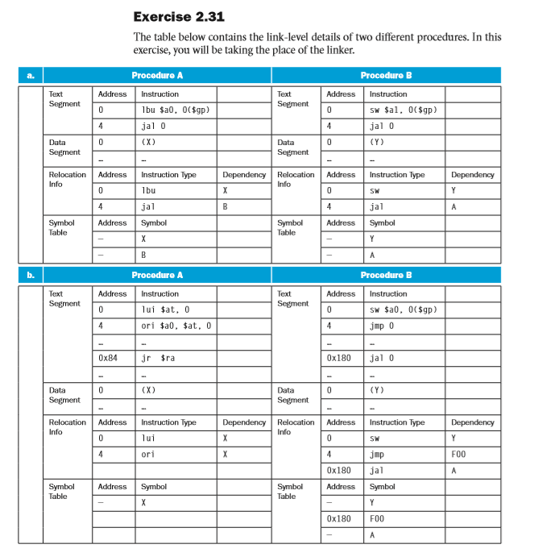

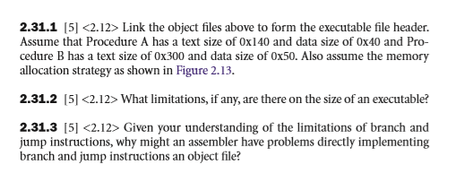

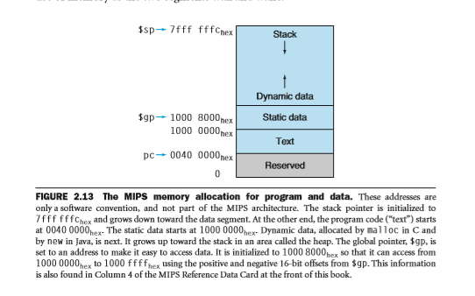

1. Exercise 4.2.2
2. Exercise 4.2.3
3. Exercise 4.2.4

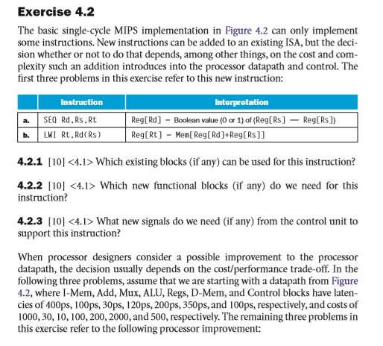

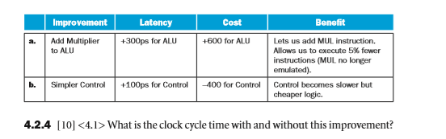

1. Exercise 4.6.5

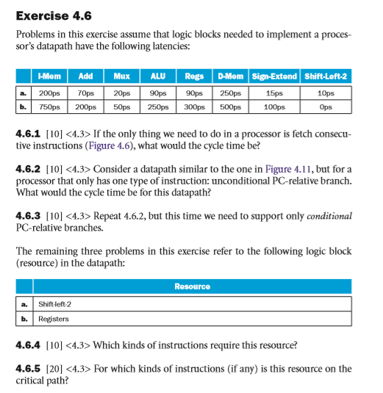

1. Exercise 4.7.1
2. Exercise 4.7.2
3. Exercise 4.7.3

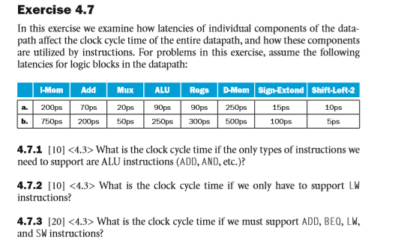

1. Exercise 4.8.1
2. Exercise 4.8.2

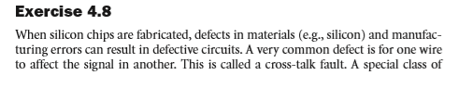

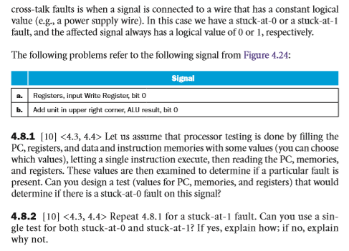

1. Exercise 4.11.2
2. Exercise 4.11.3

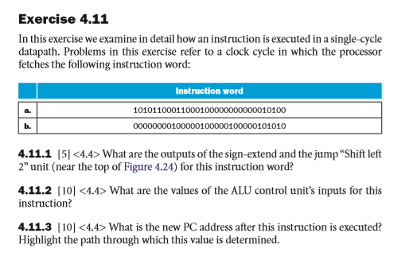

1. Modify the MIPS single cycle implementation based on following figure to support the instruction BNE.
2. Modify the MIPS single cycle implementation based on following figure to support the instruction JAL.
3. Modify the MIPS single cycle implementation based on following figure to support the instruction JR.

